OS LAB 8 TASKS
Syed Sultan Ahmed, 24K-0585
BCS-4H

Q1)
#include <stdio.h>
#include <stdlib.h>
#include <unistd.h>
#include <fcntl.h>
#include <pthread.h>
#include <sys/stat.h>

typedef struct fileTrack {
int tNum;
long startByte;
long endByte;
char* fileName;
int lines;
} fileTrack;

#define NUMTHREADS 4

void* readFile(void* arg) {
fileTrack *fData = (fileTrack *)arg;
int fd = open(fData->fileName, O_RDONLY);
if (fd < 0) {
perror("Open failed");
pthread_exit(NULL);
}

lseek(fd, fData->startByte, SEEK_SET);
char buffer;
long currentPos = fData->startByte;

while (currentPos < fData->endByte) {
if (read(fd, &buffer, 1) <= 0) break;
if (buffer == '\n') {
fData->lines++;
}
currentPos++;
}
close(fd);
pthread_exit(NULL);
}

int main() {
char* fileName = "data.txt";
struct stat st;

if (stat(fileName, &st) != 0) {
perror("Stat failed");
return 1;
}

long fileSize = st.st_size;
long bytesPerThread = fileSize / NUMTHREADS;

pthread_t threads[NUMTHREADS];
fileTrack tData[NUMTHREADS];

printf("File size: %ld bytes. Dividing into %d parts.\n", fileSize, NUMTHREADS);

for (int i = 0; i < NUMTHREADS; i++) {
tData[i].tNum = i;
tData[i].fileName = fileName;
tData[i].lines = 0;
tData[i].startByte = i * bytesPerThread;
if (i == NUMTHREADS - 1) {
tData[i].endByte = fileSize;
} else {
tData[i].endByte = (i + 1) * bytesPerThread;
}
pthread_create(&threads[i], NULL, readFile, &tData[i]);
}

int total = 0;
for (int i = 0; i < NUMTHREADS; i++) {
pthread_join(threads[i], NULL);
total += tData[i].lines;
printf("Thread %d counted %d lines\n",
i, tData[i].lines);
}
printf("Total requests: %d\n", total);
return 0;
}

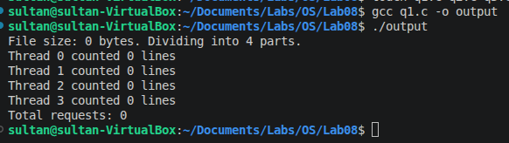

Q2)
#include <stdio.h>
#include <stdlib.h>
#include <unistd.h>
#include <pthread.h>
#include <time.h>

#define NUM_REGIONS 5
#define NUM_PARTIES 10
#define REGIONSIZE 12
typedef struct threadData {
int region[REGIONSIZE];
int votesCount;
int votesPerParty[NUM_PARTIES];
} threadData;

void* countVotes(void* arg) {
threadData* data = (threadData *)arg;
for (int i = 0; i < NUM_PARTIES; i++) {
data->votesPerParty[i] = 0;
}
data->votesCount = 0;
for (int i = 0; i < REGIONSIZE; i++) {
int partyId = data->region[i];
if (partyId >= 0 && partyId < NUM_PARTIES) {
data->votesCount++;
data->votesPerParty[partyId]++;
}
}
pthread_exit(0);
}

int main() {
srand(time(NULL));
pthread_t threads[NUM_REGIONS];
threadData data[NUM_REGIONS];
for (int i = 0; i < NUM_REGIONS; i++) {
for (int j = 0; j < REGIONSIZE; j++) {
data[i].region[j] = (rand() % (NUM_PARTIES + 3)) - 2; // waste incorrect votes
}
pthread_create(&threads[i], NULL, countVotes, &data[i]);
}
int totalCorrectVotes = 0;
int globalPartyVotes[NUM_PARTIES] = {0};
for (int i = 0; i < NUM_REGIONS; i++) {
pthread_join(threads[i], NULL);
printf("Region %d results collected. Correct votes: %d/%d\n", i, data[i].votesCount, REGIONSIZE);
for (int p = 0; p < NUM_PARTIES; p++) {
globalPartyVotes[p] += data[i].votesPerParty[p];
}
}
printf("Final Election Results\n");
for (int i = 0; i < NUM_PARTIES; i++) {
printf("Party %d: %d votes\n", i, globalPartyVotes[i]);
}
return 0;
}

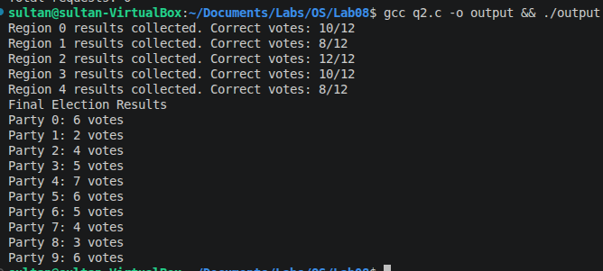

Q3)
#include <stdio.h>
#include <stdlib.h>
#include <unistd.h>
#include <pthread.h>
#include <time.h>

#define NUMSTUDENTS 50

void* calcAverage(void* arg) {

int* students = (int *) arg;
float* avg = malloc(sizeof(float));
*avg = 0;
for (int i = 0; i < NUMSTUDENTS; i++) {
*avg += students[i];
}
*avg /= NUMSTUDENTS;
pthread_exit(avg);
}

void* findHighest(void* arg) {

int* students = (int *)arg;
int* highest = malloc(sizeof(int));
if (NUMSTUDENTS <= 0) {
pthread_exit(NULL);
}
*highest = students[0];
for (int i = 1; i < NUMSTUDENTS; i++) {
if (students[i] > *highest) {
*highest = students[i];
}
}
pthread_exit(highest);
}

void* findLowest(void* arg) {

int* students = (int *)arg;
int* lowest = malloc(sizeof(int));
if (NUMSTUDENTS <= 0) {
pthread_exit(NULL);
}
*lowest = students[0];
for (int i = 1; i < NUMSTUDENTS; i++) {
if (students[i] < *lowest) {
*lowest = students[i];
}
}
pthread_exit(lowest);

}

void* getPassed(void* arg) {

int* students = (int *)arg;
int* num = malloc(sizeof(int));
*num = 0;
if (NUMSTUDENTS <= 0) {
pthread_exit(NULL);
}
for (int i = 1; i < NUMSTUDENTS; i++) {
if (students[i] >= 50) {
(*num)++;
}
}
pthread_exit(num);
}

int main() {

srand(time(NULL));
int students[NUMSTUDENTS];
for (int i = 0; i < NUMSTUDENTS; i++) {
students[i] = rand() % 100 + 1;
}

pthread_t avg_thread;
pthread_t highest_thread;
pthread_t lowest_thread;
pthread_t passed_thread;

pthread_create(&avg_thread, NULL, calcAverage, &students);
pthread_create(&highest_thread, NULL, findHighest, &students);
pthread_create(&lowest_thread, NULL, findLowest, &students);
pthread_create(&passed_thread, NULL, getPassed, &students);

float* avg;
pthread_join(avg_thread, (void **)&avg);
int* highest;
pthread_join(highest_thread,(void **)&highest);
int* lowest;
pthread_join(lowest_thread, (void **)&lowest);
int* passed;
pthread_join(passed_thread, (void **)&passed);

printf("Student Marks: ");
for(int i = 0; i < NUMSTUDENTS; i++) {
printf("%d, ", students[i]);
}
printf("\nAvg: %.2f, Highest: %d, Lowest: %d, NumPassed: %d out of %d\n",
*avg, *highest, *lowest, *passed, NUMSTUDENTS);

free(avg); free(highest); free(lowest); free(passed);
}

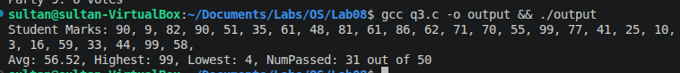

Q4)
#include <stdio.h>
#include <stdlib.h>
#include <unistd.h>
#include <string.h>
#include <pthread.h>
#include <fcntl.h>

#define NUMTHREADS 5

typedef struct threadData {
char* filename;
int startByte;
int endByte;
char* keyword;
int instances;
} threadData;

void* findInstances(void* arg) {

threadData* data = (threadData *)arg;
int fd = open(data->filename, O_RDONLY);
if ( fd < 0 ) {
perror("file open failed\n");
pthread_exit(NULL);
}

lseek(fd, data->startByte, SEEK_SET);

int k = strlen(data->keyword);
char* str = malloc((sizeof(char)*k) + 1);
for(int i = data->startByte; i + k <= data->endByte; i++) {
lseek(fd, i, SEEK_SET);
read(fd, str, k);
str[k] = 0;
if (strcmp(str, data->keyword) == 0) {
data->instances++;
}
}
close(fd);
free(str);
pthread_exit(NULL);
}

int main() {

char* filename = "data.txt";
char* keyword = "login";

int fd = open(filename, O_RDONLY);
if (fd < 0) {
perror("Couldn't open file\n");
return -1;
}

int fileSize = lseek(fd,0, SEEK_END);
lseek(fd, 0, SEEK_SET);

int segmentSize = fileSize/NUMTHREADS;
int remainder = fileSize % NUMTHREADS;

int k = strlen(keyword);

threadData data[NUMTHREADS];
pthread_t threads[NUMTHREADS];
for(int i = 0; i < NUMTHREADS; i++) {
int startByte = (segmentSize * i);
int endByte = (segmentSize * (i + 1));
if (i != NUMTHREADS - 1) {
endByte += k;
} else {
endByte += remainder;
}
data[i].filename = filename;
data[i].keyword = keyword;
data[i].instances = 0;
data[i].startByte = startByte;
data[i].endByte = endByte;
pthread_create(&threads[i], NULL, findInstances, &data[i]);
}
int total = 0;
for (int i = 0; i < NUMTHREADS; i++) {
pthread_join(threads[i], NULL);
printf("Thread %d found %d instances\n", i, data[i].instances);
total += data[i].instances;
}
printf("Total instances: %d\n", total);
}

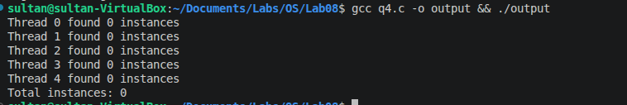

Q5)
#include <stdio.h>
#include <stdlib.h>
#include <unistd.h>
#include <pthread.h>
#include <time.h>
#include <stdbool.h>

#define NUMTHREADS 5
#define NUMELEMENTS 50

typedef struct threadData {
int startIndex;
int endIndex;
int* array;
int numPrimes;
} threadData;

bool isPrime(int num) {
if ( num <= 2) {
return true;
}
for (int i = 2; i*i <= num; i++) {
if ( num % i == 0 ) {
return false;
}
}
return true;
}

void* findPrimes(void* arg) {
threadData* data = (threadData *) arg;
for (int i = data->startIndex; i < data->endIndex; i++) {
if (isPrime(data->array[i])) {
data->numPrimes++;
}
}
pthread_exit(NULL);
}

int main() {
srand(time(NULL));
int numbers[NUMELEMENTS];
for (int i = 0; i < NUMELEMENTS; i++) {
numbers[i] = rand() % 500 + 1;
}

pthread_t threads[NUMTHREADS];
threadData data[NUMTHREADS];
int size = NUMELEMENTS/NUMTHREADS;
int remainder = NUMELEMENTS % NUMTHREADS;
for (int i = 0; i < NUMTHREADS; i++) {
int startIndex = (i * size);
int endIndex = ((i + 1) * size);
if ( i == NUMTHREADS -1 ){
endIndex += remainder;
}
data[i].startIndex = startIndex;
data[i].endIndex = endIndex;
data[i].numPrimes = 0;
data[i].array = numbers;
pthread_create(&threads[i], NULL, findPrimes, &data[i]);
}
int total = 0;
for (int i = 0; i < NUMTHREADS; i++) {
pthread_join(threads[i], NULL);
printf("Thread %d found %d primes\n", i, data[i].numPrimes);
total += data[i].numPrimes;
}
printf("Total primes: %d\n", total);

}

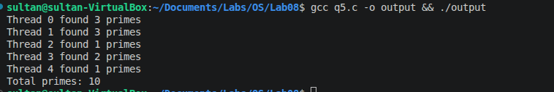

Q6)
#include <stdio.h>
#include <stdlib.h>
#include <unistd.h>
#include <pthread.h>

#define NUMTHREADS 5

typedef struct threadData {
int transactionType;
int amount;
int* balance;
} threadData;

void* processTransaction(void* arg) {

threadData* data = (threadData*)arg;
int temp = *(data->balance);
if (data->transactionType == 0) {
printf("Deposit: %d\n", data->amount);
temp += data->amount;
} else {
printf("Withdraw: %d\n", data->amount);
temp -= data->amount;
}
usleep(1000);
*(data->balance) = temp;
pthread_exit(NULL);
}

int main() {
int balance = 1000;
printf("Initial balance: %d\n", balance);
threadData data[NUMTHREADS];
pthread_t threads[NUMTHREADS];
for (int i = 0; i < NUMTHREADS; i++) {
data[i].balance = &balance;
data[i].amount = rand() % 200 + 1;
data[i].transactionType = rand() % 2;

pthread_create(&threads[i], NULL, processTransaction, &data[i]);
}

for (int i = 0; i < NUMTHREADS; i++) {
pthread_join(threads[i], NULL);
}
printf("Final Balance: %d\n", balance);

}

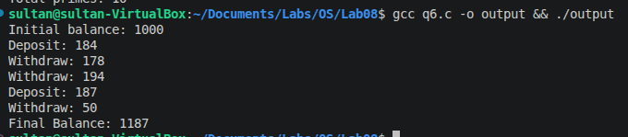

Q7)
#include <stdio.h>
#include <stdlib.h>
#include <unistd.h>
#include <string.h>
#include <pthread.h>
#include <fcntl.h>

#define NUMTHREADS 4

typedef struct threadData {
char* filename;
char* keyword;
int instances;
} threadData;

void* findInstances(void* arg) {

threadData* data = (threadData *)arg;
int fd = open(data->filename, O_RDONLY);
if ( fd < 0 ) {
perror("file open failed\n");
pthread_exit(NULL);
}

int endByte = lseek(fd, 0, SEEK_END);
lseek(fd, 0, SEEK_SET);
char* ch = malloc(sizeof(char));
int inword = 0;
for(int i = 0; i <= endByte; i++) {
read(fd, ch, 1);
if (!(*ch == ' ' || *ch == ',' || *ch == '.' || *ch == '\n' || *ch == '.'
|| *ch == '!' || *ch == '?' || *ch == ';' || *ch == ':')) {
if (inword == 0) {
data->instances++;
inword = 1;
}
} else {
inword = 0; //
}
}
close(fd);
free(ch);
pthread_exit(NULL);
}

int main() {

char* filenames[NUMTHREADS] = {
"file1.txt", "file2.txt", "file3.txt", "file4.txt"
};

threadData data[NUMTHREADS];
pthread_t threads[NUMTHREADS];
for(int i = 0; i < NUMTHREADS; i++) {
data[i].filename = filenames[i];
data[i].instances = 0;
pthread_create(&threads[i], NULL, findInstances, &data[i]);
}
int total = 0;
for (int i = 0; i < NUMTHREADS; i++) {
pthread_join(threads[i], NULL);
printf("Thread %d found %d words from %s\n", i, data[i].instances, data[i].filename);
total += data[i].instances;
}
printf("Total words: %d\n", total);
}

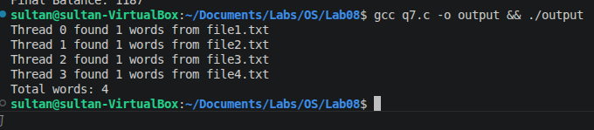

Q8)
#include <stdio.h>
#include <stdlib.h>
#include <unistd.h>
#include <time.h>
#include <pthread.h>

typedef struct review {
int id;
int rating;
} review;

typedef struct tData {
review* reviews;
int startIndex;
int endIndex;
float avg;
} threadData;

void* calcAvg(void *arg) {
int sum = 0;
threadData* data = (threadData *)arg;
for (int i = data->startIndex; i < data->endIndex; i++) {
sum += data->reviews[i].rating;
}
data->avg = (float)sum/(data->endIndex-data->startIndex);
pthread_exit(0);
}

#define NUMREVIEWS 13
#define NUMTHREADS 3

int main() {
srand(time(NULL));

review reviews[NUMREVIEWS];
for (int i = 0; i < NUMREVIEWS; i++) {
reviews[i].rating = rand() % 5 + 1;
reviews[i].id = i;
}
printf("Reviews arr:\n");
for (int i = 0; i < NUMREVIEWS; i++) {
printf("Review %d: %d\n", reviews[i].id, reviews[i].rating);
}
threadData data[NUMTHREADS];
pthread_t threads[NUMTHREADS];
int reviewsPerThread = NUMREVIEWS / NUMTHREADS;
int remainder = NUMREVIEWS % NUMTHREADS;
for (int i = 0; i < NUMTHREADS; i++) {
int startIndex = i * reviewsPerThread;
int endIndex = (i + 1) * reviewsPerThread;
if (i == NUMTHREADS - 1) {
endIndex += remainder;
}
data[i].reviews = reviews;
data[i].startIndex = startIndex;
data[i].endIndex = endIndex;
data[i].avg = 0;
pthread_create(&threads[i], NULL, calcAvg, &data[i]);
}

float combinedSum = 0;
for (int i = 0; i < NUMTHREADS; i++) {
pthread_join(threads[i], NULL);
printf("Thread %d avg: %.2f\n", i, data[i].avg);
int count = data[i].endIndex - data[i].startIndex;
combinedSum += (data[i].avg * count);
}
float finalAvg = combinedSum / NUMREVIEWS;
printf("Overall Average Rating: %.2f\n", finalAvg);
}
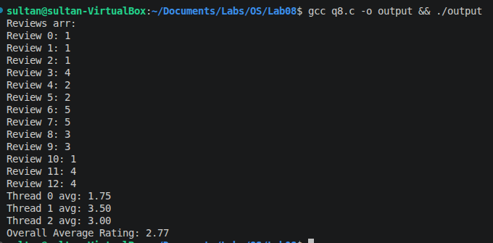

Q9)
#include <stdio.h>
#include <stdlib.h>
#include <unistd.h>
#include <time.h>
#include <pthread.h>

// 0 = square, 1 = cube, 2 = factorial
typedef struct task {
int input;
int type;
} task;

typedef struct result {
long value;
} result;

typedef struct threadData {
task* tasks;
result* results;
int startIndex;
int endIndex;
} threadData;

long calcFact(int n) {
if (n <= 1) return 1;
long res = 1;
for (int i = 2; i <= n; i++) res *= i;
return res;
}

void* processTasks(void *arg) {
threadData* data = (threadData *)arg;
for (int i = data->startIndex; i < data->endIndex; i++) {
int val = data->tasks[i].input;
int type = data->tasks[i].type;
if (type == 0) {
data->results[i].value = (long)val * val;
} else if (type == 1) {
data->results[i].value = (long)val * val * val;
} else if (type == 2) {
data->results[i].value = calcFact(val);
}
}
pthread_exit(0);
}

#define NUMTASKS 10
#define NUMTHREADS 3

int main() {
srand(time(NULL));

task tasks[NUMTASKS];
result results[NUMTASKS];
printf("Server Received Tasks\n");
for (int i = 0; i < NUMTASKS; i++) {
tasks[i].input = rand() % 10 + 1;
tasks[i].type = rand() % 3;
char* typeStr = (tasks[i].type == 0) ? "Square" : (tasks[i].type == 1 ? "Cube" : "Factorial");
printf("Task %d: %s of %d\n", i, typeStr, tasks[i].input);
}

threadData data[NUMTHREADS];
pthread_t threads[NUMTHREADS];

int tasksPerThread = NUMTASKS / NUMTHREADS;
int remainder = NUMTASKS % NUMTHREADS;
for (int i = 0; i < NUMTHREADS; i++) {
int startIndex = i * tasksPerThread;
int endIndex = (i + 1) * tasksPerThread;
if (i == NUMTHREADS - 1) {
endIndex += remainder;
}
data[i].tasks = tasks;
data[i].results = results;
data[i].startIndex = startIndex;
data[i].endIndex = endIndex;
pthread_create(&threads[i], NULL, processTasks, &data[i]);
}

for (int i = 0; i < NUMTHREADS; i++) {
pthread_join(threads[i], NULL);
}
printf("Final Processed Results\n");
for (int i = 0; i < NUMTASKS; i++) {
char* typeStr = (tasks[i].type == 0) ? "Square" : (tasks[i].type == 1 ? "Cube" : "Factorial");
printf("Task %d [%s of %d]: %ld\n", i, typeStr, tasks[i].input, results[i].value);
}

return 0;
}

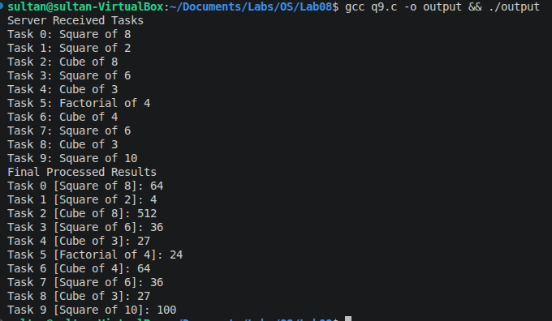

Q10)
#include <stdio.h>
#include <stdlib.h>
#include <unistd.h>
#include <pthread.h>
#include <time.h>

#define NUM_REGIONS 5
#define NUM_PARTIES 10
#define REGIONSIZE 12
typedef struct threadData {
int region[REGIONSIZE];
int votesCount;
int votesPerParty[NUM_PARTIES];
} threadData;

void* countVotes(void* arg) {
threadData* data = (threadData *)arg;
for (int i = 0; i < NUM_PARTIES; i++) {
data->votesPerParty[i] = 0;
}
data->votesCount = 0;
for (int i = 0; i < REGIONSIZE; i++) {
int partyId = data->region[i];
if (partyId >= 0 && partyId < NUM_PARTIES) {
data->votesCount++;
data->votesPerParty[partyId]++;
}
}
pthread_exit(0);
}

int main() {
srand(time(NULL));
pthread_t threads[NUM_REGIONS];
threadData data[NUM_REGIONS];
for (int i = 0; i < NUM_REGIONS; i++) {
for (int j = 0; j < REGIONSIZE; j++) {
data[i].region[j] = (rand() % (NUM_PARTIES + 3)) - 2;
}
pthread_create(&threads[i], NULL, countVotes, &data[i]);
}
int totalCorrectVotes = 0;
int globalPartyVotes[NUM_PARTIES] = {0};
for (int i = 0; i < NUM_REGIONS; i++) {
pthread_join(threads[i], NULL);
printf("Region %d results collected. Correct votes: %d/%d\n", i, data[i].votesCount, REGIONSIZE);
for (int p = 0; p < NUM_PARTIES; p++) {
globalPartyVotes[p] += data[i].votesPerParty[p];
}
}
printf("Final Election Results\n");
for (int i = 0; i < NUM_PARTIES; i++) {
printf("Party %d: %d votes\n", i, globalPartyVotes[i]);
}
return 0;
}

